Project Design Phase-II
Technology Stack (Architecture & Stack)

Date | 22 February 2026
Team ID | LTVIP2026TMIDS42033
Project Name | Weather-Based Prediction of Wind Turbine Energy Output: A Next-Generation Approach to Renewable Energy Management
Maximum Marks | 4 Marks

Technical Architecture:
The Deliverable shall include the architectural diagram as below and the information as per the table1 & table 2
Example:
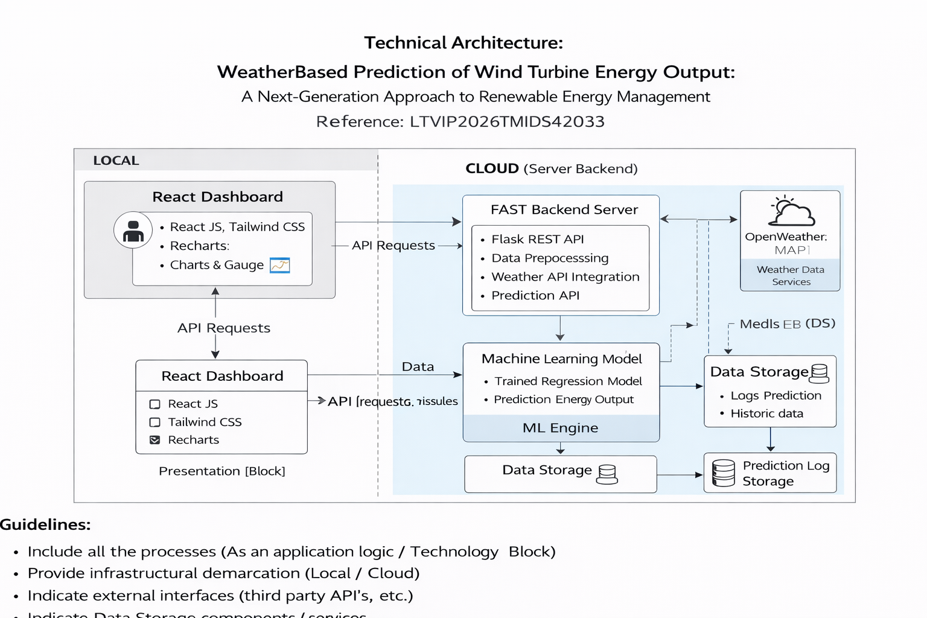
Table-1 : Components & Technologies:
S.No | Component | Description | Technology
 | User Interface | Web-based dashboard | React, TypeScript
 | Application Logic | API & ML integration | Python Flask
 | Weather API | Real-time weather data | OpenWeatherMap API
 | ML Model | Predict energy output | Scikit-learn / XGBoost
 | Database | Dataset storage | CSV / Local Storage
 | Visualization | Charts & analytics | Recharts
 | Infrastructure | Local Deployment | Windows Localhost

Table-2: Application Characteristics:
S.No | Characteristics | Description | Technology
 | Open-Source Frameworks | Frontend & ML libraries | React, Flask, Scikit-learn
 | Security Implementations | API Key protection | .env configuration
 | Scalable Architecture | 3-tier design | REST-based structure
 | Availability | Runs locally & cloud deployable | Docker (Future)
 | Performance | Fast API calls & prediction | Optimized ML model

References:
[1] S. Brown, “The C4 Model for Visualising Software Architecture,” C4Model.com. [Online]. Available: https://c4model.com/
[2] IBM, “IBM Cloud Architecture Center,” IBM Cloud, 2024. [Online]. Available: https://www.ibm.com/cloud/architecture
[3] Amazon Web Services, “AWS Architecture Center,” AWS Documentation. [Online]. Available: https://aws.amazon.com/architecture/
[4] IBM Developer, “Online Order Processing System During Pandemic,” IBM Developer Patterns. [Online]. Available: https://developer.ibm.com/patterns/online-order-processing-system-during-pandemic/
[5] S. Koen, “How to Draw Useful Technical Architecture Diagrams,” Medium, 2020. [Online]. Available: https://medium.com/the-internal-startup/how-to-draw-useful-technical-architecture-diagrams-2d20c9fda90d
[6] OpenWeather Ltd., “OpenWeatherMap API Documentation,” 2024. [Online]. Available: https://openweathermap.org/api
[7] F. Pedregosa et al., “Scikit-Learn: Machine Learning in Python,” Journal of Machine Learning Research, 2011. [Online]. Available: https://scikit-learn.org/
[8] T. Chen and C. Guestrin, “XGBoost: A Scalable Tree Boosting System,” Proceedings of the 22nd ACM SIGKDD Conference, 2016. [Online]. Available: https://xgboost.readthedocs.io/
[9] J. Grisel et al., “Joblib: Running Python Functions as Pipeline Jobs,” 2024. [Online]. Available: https://joblib.readthedocs.io/
[10] React Team, “React – A JavaScript Library for Building User Interfaces,” Meta, 2024. [Online]. Available: https://react.dev/
[11] Vite Contributors, “Vite Documentation,” 2024. [Online]. Available: https://vitejs.dev/
[12] A. Ronacher, “Flask Documentation,” Pallets Project, 2024. [Online]. Available: https://flask.palletsprojects.com/
[13] Recharts Contributors, “Recharts – A Composable Charting Library Built on React,” 2024. [Online]. Available: https://recharts.org/
[14] R. Cabello et al., “Three.js Documentation,” 2024. [Online]. Available: https://threejs.org/
[15] International Renewable Energy Agency (IRENA), “Wind Energy Overview,” 2024. [Online]. Available: https://www.irena.org/
[16] U.S. Department of Energy, “Wind Energy Technologies Office,” 2024. [Online]. Available: https://www.energy.gov/eere/wind/wind-energy-technologies-office
[17] Global Wind Energy Council (GWEC), “Global Wind Report,” 2024. [Online]. Available: https://gwec.net/

